**OOPS**



**LAB Task 7**

**Name: Shakeel Ahmad**

**Roll No: F24-720**

**Program: BSSE**

**Semester/Section: 2nd and Section ‘E’**

**Subject: Object Oriented Programming**

**Session: Spring 2025**

**Submitted To: Miss Kinza Naqvi**

**Department of Computer Science**

**Abbottabad University of Science & Technology**

**Question No: 1**

**Program:**

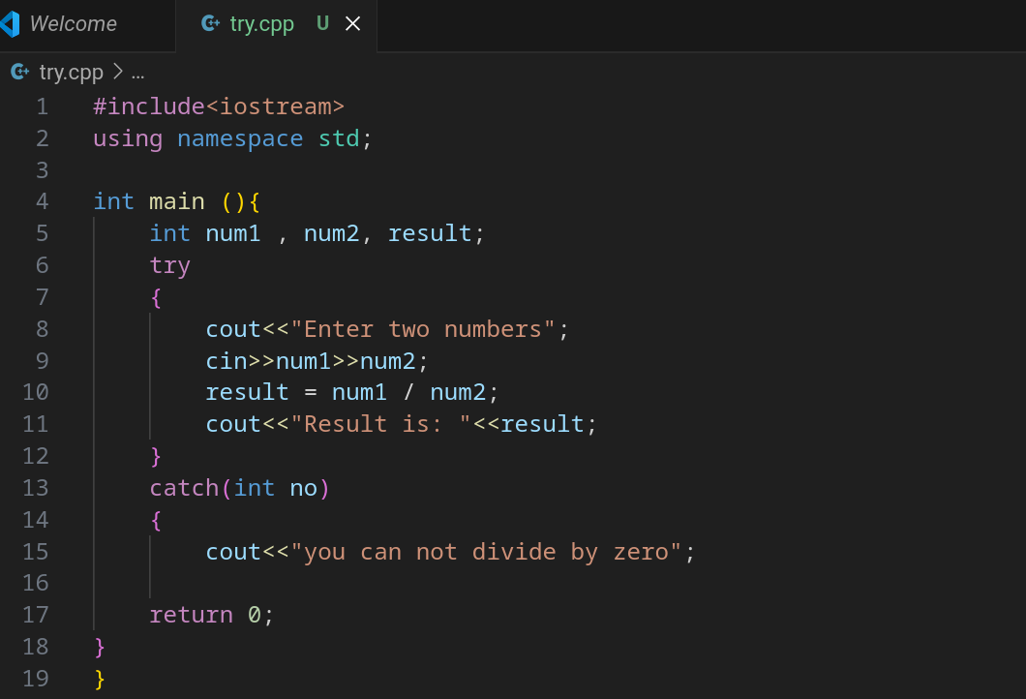

**Output:**

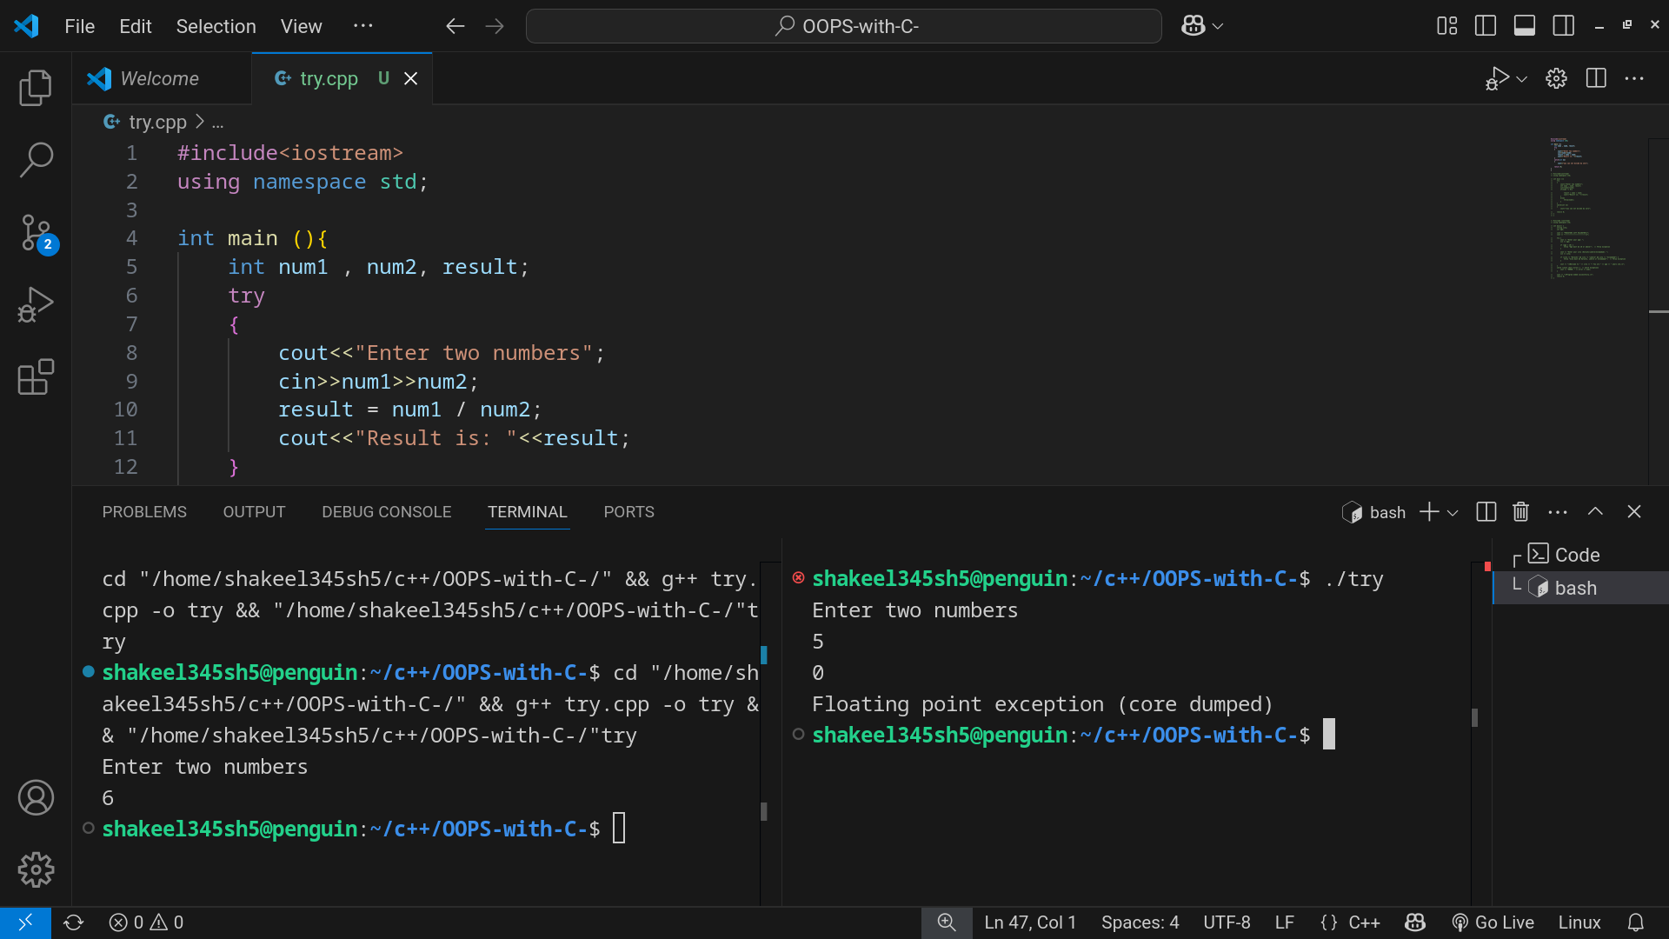

**Question No: 2**

**Coding:**

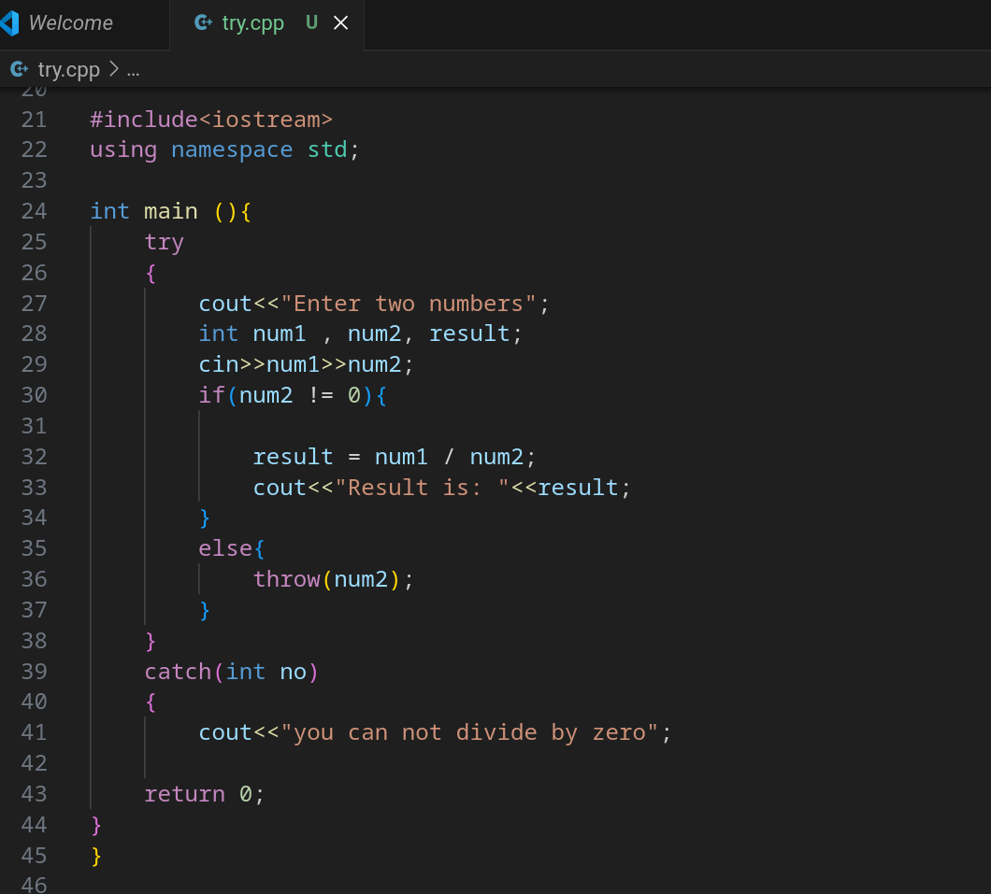

**Output:**

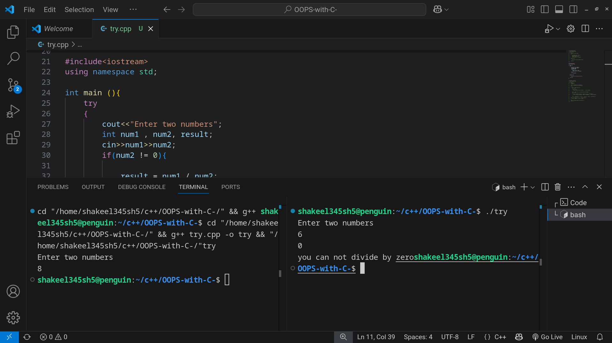

**Question No: 3**

**Coding:**

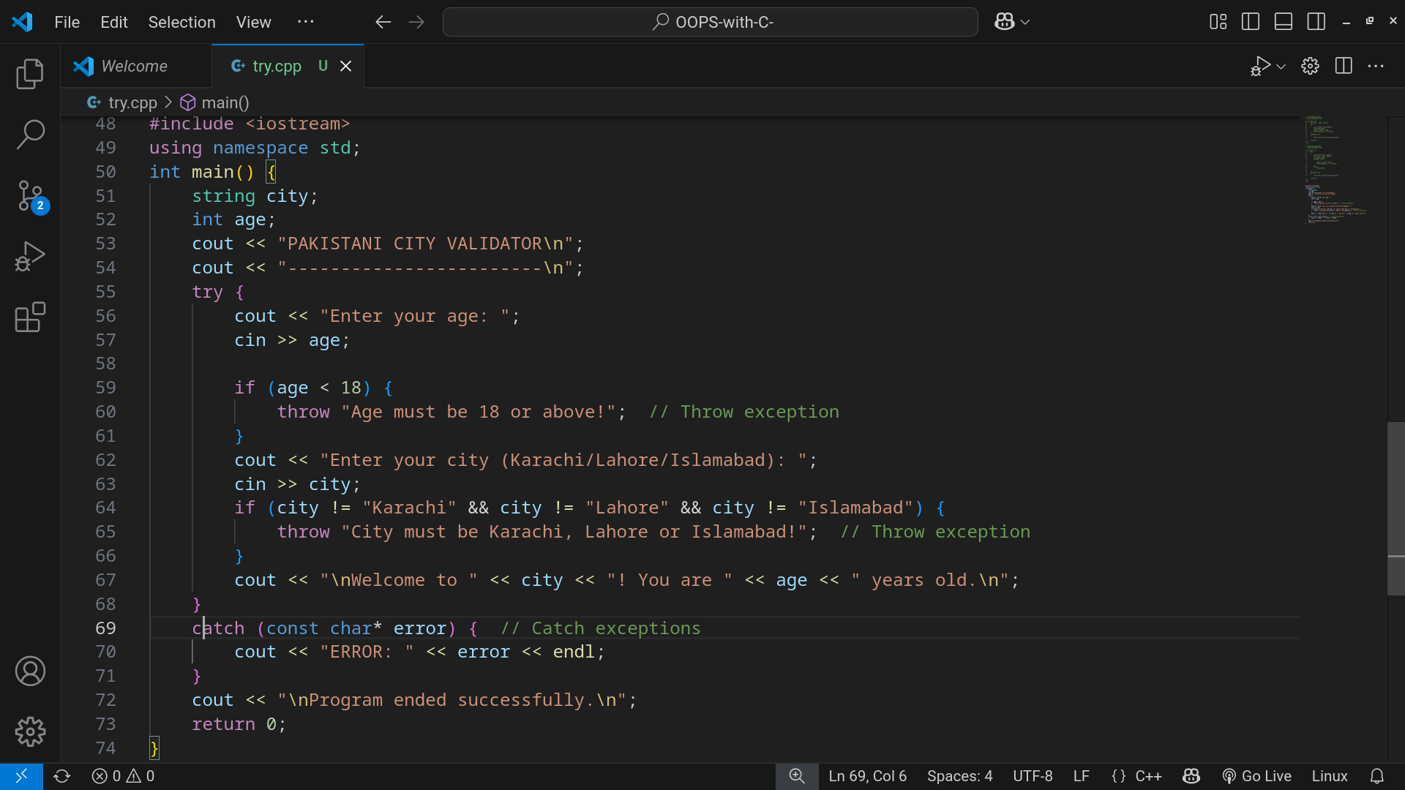

**Output:**

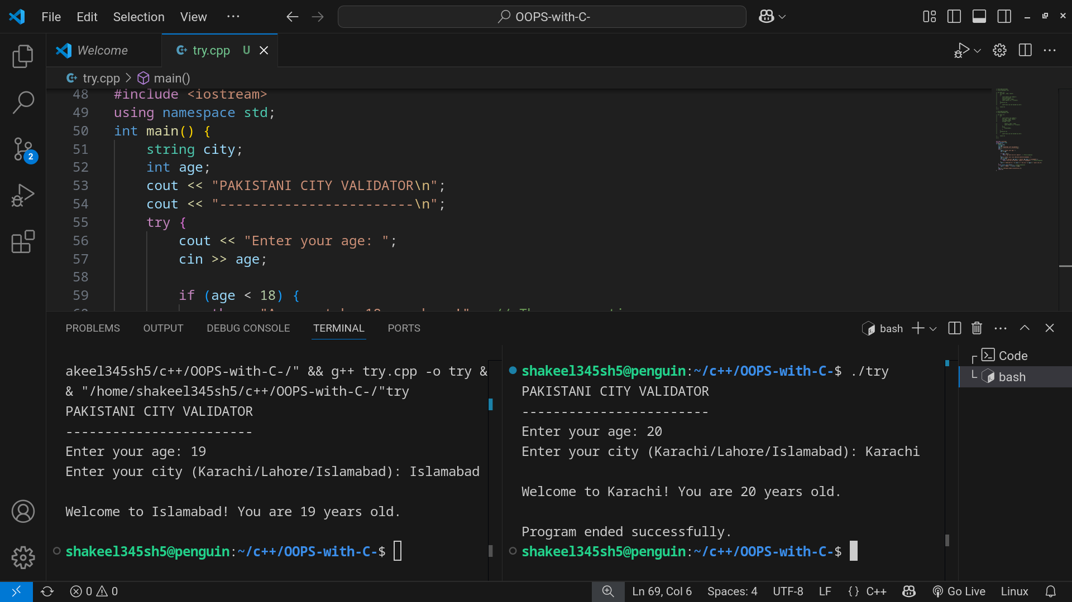

**Name: Shakeel Ahmad**

**Roll No: F24-720**

**Submitted to: Mam Kinza Naqvi**

**Date: 19-May-2025**